Nutritional management of high output enterocutaneous fistula : case report
Eka Maya Sari¹, Mawaddah Nurrahma²
¹Clinical Nutrition Department, Awal Bros Hospital, Pekanbaru-Indonesia
²Medical Service, Awal Bros Hospital, Pekanbaru-Indonesia
*Corresponding author, dr. Eka Maya Sari, M.Gizi, SpGK (ekamayasari81@gmail.com)
Abstract
Enterocutaneous fistula is a common post-operative gastrointestinal surgery complication with high morbidity and mortality rate. High morbidity and mortality rate in enterocutaneous fistula is due to malnutrition, dehydration and electrolyte disturbances. Comprehensive management needed to support optimal therapy of enterocutaneous fistula including nutritional therapy. We present of a case of an enterocutaneous fistula after gastrointestinal surgery which cause malnutrition. This case demonstrates that adequate nutritional management of enterocutaneous fistula plays important role in healing process.

Keyword : enterocutaneous fistula, gastrointestinal surgery, nutritional management, partial parenteral

Introduction
Enterocutaneous fistula is a post-operative complication that occurs quite frequently. Approximately 75-85% of gastrointestinal surgery have a risk of becoming an enterocutaneous fistula within 5-10 days after surgery and remains a health burden worldwide.^{1,2} Patients with enterocutaneous fistulas have a high risk of experiencing malnutrition, dehydration and electrolyte disturbances commonly known as the fistula triad.³ This will reduce the body's ability to close the fistula spontaneously and increase the mortality rate.^{1,2,4}
The mortality rate due to enterocutaneous fistula reached 40% as a result of malnutrition and sepsis.⁴ With comprehensive management including optimal nutritional therapy, the mortality rate of enterocutaneous fistula can be reduced significantly by up to 50%.^{2,4} Comprehensive management of enterocutaneous fistula is needed from various fields of medicine
such as surgery, nutrition, wound care and pharmacy. In this case report, we will discuss how nutritional management plays an important role in the healing process of enterocutaneous fistula.
Case Presentation
DA, a 16-year-old child came to the Hospital complaining of abdominal pain and bloating since 1 day ago. The patient had a history of partial obstructive ileus which was managed conservatively. The patient's medical examination showed that patient was suffering from upper gastrointestinal obstructive caused by adhesions due to inflammation. Immediate laparotomy surgery was planned to release the obstruction. The patient was feed gradually with liquid food since the first day after surgery and he can tolerate soft diet on the third day.
On the 6th day after surgery, the patient complained of bloating, abdominal pain, fever and there was a discharge from the surgical scar. The surgeon then partially opened the surgical sutures and inserted a colostomy bag to collect the discharge and confirm the diagnosis of enterocutaneous fistula. On the 22nd day after surgery, the patient was consulted with the physician nutrition specialist to receive optimal nutritional therapy.
The patient's nutritional status upon admission to the Hospital was normo-weight with a body mass index (BMI) 21.48 kg/m2. However, on the 22th day of admission, the patient was already in a state of moderate malnutrition with 10 kg weight loss and BMI 17.57 kg/m2. The last laboratory test results before the consultation revealed anemia (Hb 5.4 g/dL), leukocytosis (leukocytes 44,160/µL), thrombocytosis (platelets 550,000/µL), and hypoalbuminemia (albumin 2.15 g/dL). Kidney function tests revealed creatinine 0.65 mg/dL and hyponatremia (Na 123 mmol/L).
Physician nutrition specialist diagnosed the patient with moderate malnutrition in condition of enterocutaneous fistula after laparotomy and ileo-ileal resection-anastomosis due to indications of upper gastrointestinal obstruction due to adhesions. Fistula production reached 700 ml/24 hours in the form of digestive tract material so it was categorized as a high output fistula with a negative fluid balance of 400 ml/24 hours.
Nutritional management for patients is given at 1900-2000 kcal, with protein of 1.5-2 g/kg body weight, in the form of a soft diet of 850 kcal orally with partial parenteral nutrition of 1038 kcal. Oral hydration is limited to a maximum of 500 ml/day. The micronutrients provided are a combination of 1000 mg of vitamin C, 100 mg of vitamin B1, 100 mg of vitamin B6, 5000 mcg of vitamin B12, 800 mg of magnesium and 200 mg of calcium. Within 12 days of receiving optimal nutritional therapy, enterocutaneous fistula production became 540 ml/day, 100 ml/day , 40 ml/day and stopped. Parenteral nutrition is discontinued when the fistula is no longer producing, and oral nutrition can be increased. On the 33rd day hospitalization, parenteral nutrition can be discontinued and nutrition therapy administered entirely by oral nutrition.
Patients are also given antibiotic therapy according to the patient's blood culture, 4 times of 250 ml packed red cells (PRC) for transfusion of red blood cell, 3 times albumin correction with 100 ml of Plasbumin® 20% and electrolyte monitoring until enterocutaneous fistula closure can be achieved. Fluid balance is closely monitored by administering fluids to correct negative balance intravenously to reduced enterocutaneous fistulas production. Within 12 days of optimal nutritional management through a combination of oral and parenteral nutrition with micronutrient supplementation that supports wound healing, fistula production decreased and the enterocutaneous fistula slowly began to close. Laboratory parameters at discharge were Hb 10.5 g/dL, leukocytes 14,070/µL, platelets 500,000//µL and albumin 2.6/dL. Wound had close completely on the 2nd week after discharged from Hospital.

Table 1. Summary of patient monitoring.

Day of treatment | Weight | Laboratory | Fistulas Production | Nutritional Therapy
22 | 45 kg | Hb : 5.4  Leukocyte : 44,160  Albumin : 2.15  Sodium : 123  Potassium : 3.9  Creatinine : 0.65 | 700 ml/day | Oral : 850 kcal, protein 45 gram  Oral Hydration : max. 500 ml/24 hours  Parenteral 1038 kcal protein 34 gram  IV Micronutrient : vitamin C 1000 mg, vitamin B1 100 mg, vitamin B6 100 mg, vitamin B12 5000 mcg, magnesium 800 mg, calcium 200 mg  IV albumin correction  Red blood cells transfusion
25 | 45 kg | Hb : 9.4  Leukocyte : 11,660  Albumin : 2.06  Sodium : 130  Potassium : 4.2  Creatinine : 0.38  Urea : 22.5 | 540 ml/day | Oral : 850 kcal, protein 45 gram  Oral Hydration : max. 500 ml/24 hours  Parenteral 1038 kcal protein 34 gram  IV Micronutrient : vitamin C 1000 mg, vitamin B1 100 mg, vitamin B6 100 mg, vitamin B12 5000 mcg, magnesium 800 mg, calcium 200 mg  IV albumin correction  Red blood cells transfusion
28 | 45 kg | Hb : 11.5  Leukocyte : 19,240  Albumin : 2.28 | 100 ml/day | Oral : 850 kcal, protein 45 gram  Oral Hydration : max. 500 ml/24 hours  Parenteral 1038 kcal protein 34 gram  IV Micronutrient : vitamin C 1000 mg, vitamin B1 100 mg, vitamin B6 100 mg, vitamin B12 5000 mcg, magnesium 800 mg, calcium 200 mg  IV albumin correction
31 | 45 kg | Hb : 10.5  Leukocyte : 14,070  Albumin : 2.60 | 40 ml/day | Oral : 1000 kcal, protein 45 gram  Oral Hydration : max. 1000 ml/24 hours  Parenteral 1038 kcal protein 34 gram  IV Micronutrient : vitamin C 1000 mg, vitamin B1 100 mg, vitamin B6 100 mg, vitamin B12 5000 mcg, magnesium 800 mg, Calcium 200 mg
33 | 44 kg | - | - | Oral : 1900 kcal, protein 46 gram (1 g/kgbw)  Oral micronutrient : vitamin C 500 mg, vitamin B1 100 mg, vitamin B6 100 mg, vitamin B12 5000 mcg, zinc 40 mg
34  (discharge) | 44 kg | - | - | Oral : 1900 kcal, protein 46 gram (1 g/kgbw)  Micronutrient per oral : vitamin C 500 mg, vitamin B1 100 mg, vitamin B6 100 mg, vitamin B12 5000 mcg, zinc 40 mg

Figure 1. Enterocutaneous fistula production graph.

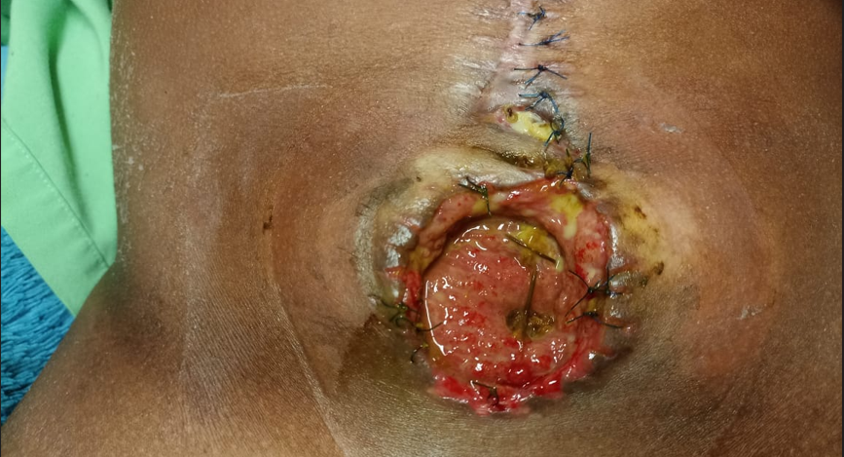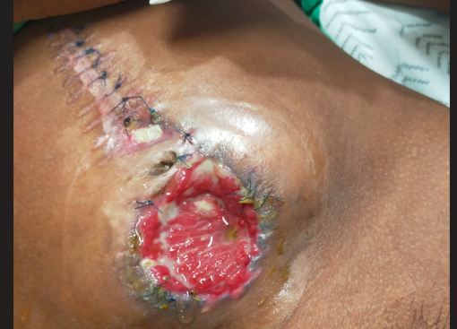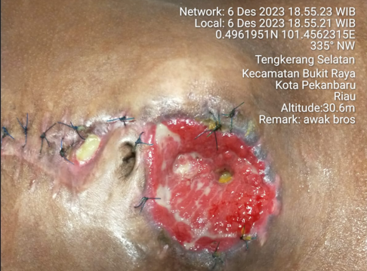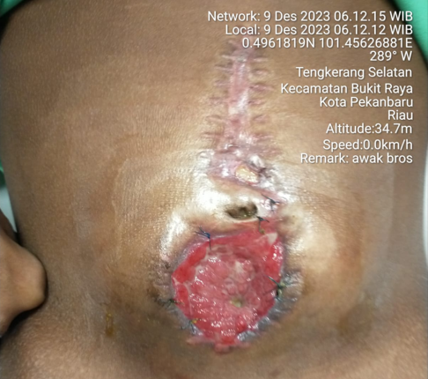
Figure 2. Enterocutaneous fistula closure process

Discussion
Enterocutaneous fistula is a common gastrointestinal surgery complication that has high morbidity and mortality rate. On this case report, patient experienced a fistula on the 6th day after gastrointestinal surgery which is the most common cause of enterocutaneous fistula.³ Patient receive early oral or enteral nutrition less than 24 hours after surgery as recommended from European Society for Clinical Nutrition (ESPEN) and Enhanced Recovery After Surgery

(ERAS) to start feeding early if there is no contraindication.^{5,6}
Carbohydrate loading has not been implemented in this case because the Hospital has not fully following the ESPEN and ERAS recommendations. Perioperative nutritional management in patients is very important to prevent post-operative complications including enterocutaneous fistula. Proper analysis of patient nutritional status, nutritional needs and evaluation of nutritional intake were not carried out, thus increasing the risk of enterocutaneous fistula complications. Until the 22nd day of treatment, the production of enterocutaneous fistulas was increasing and the surgical wounds were getting wider, so the team of doctors decided to consult to a physician nutrition specialist to obtain optimal nutritional therapy for patients with enterocutaneous fistulas.
Enterocutaneous fistula in this case report caused the patient to experience malnutrition, electrolyte imbalance and at risk of dehydration due to high out put enterocutaneous fistula production.³ There was a decrease in the patient's body weight from 55 kg to 45 kg (a decrease of 10 kg or 18%) in 22 days of hospitalization. BMI decreased from 21.48 kg/m2 to 17.57 kg/m2, with laboratory examinations showing anemia (Hb 5.4 g/dL), leukocytosis (leukocytes 44,160/µL), thrombocytosis (platelets 550,000/µL) and hypoalbuminemia (albumin 2.15 g/dL), creatinine 0.65 mg/dL and hyponatremia (Na 123 mmol/L). Fluid balance is always negative due to the production of enterocutaneous fistula reaching 700 ml/day.
Nutritional management for patients is given at 1900-2000 kcal, with protein of 1.5-2 g/kg body weight, in the form of a soft diet of 850 kcal with partial parenteral of 1038 kcal with oral hydration limited to a maximum of 500 ml/day. Research showed that providing 1500-2000 kcal of calories was proven to have a lower mortality rate of 16% compared to providing 1000 kcal of calories (58%) and the spontaneous fistula closure process was better at 89% compared to providing 1000 kcal of calories, which is only 37%.⁷ However, providing nutrition in excess of needs (overfeeding) can increase the occurrence of hyperglycemia, hepatic stenosis and increase the incidence of sepsis in patients.⁷ The process of spontaneous closure of enterocutaneous fistula is influenced by various factors, including improved nutritional status, normal serum albumin and total protein in the blood.^{8,9}
The calorie intake for this patient is 42-44 kcal/kg body weight and protein 1.5-2 g/kg body weight in accordance with the recommendation to provide calories and protein 1.5-2 times the daily requirement for patients with high output fistulas, as well as micronutrients 5 times the daily requirement.⁷ Micronutrients given to patients are a combination of 1000 mg of vitamin C, 100 mg of vitamin B1, 100 mg of vitamin B6, 5000 mcg of vitamin B12, 800 mg of magnesium and 200 mg of calcium as a micronutrient supplement for high-output enterocutaneous fistulas, supporting wound healing and fistula closure process. The administration of these micronutrients is limited to intravenous micronutrients available at the Hospital.
Vitamin C plays important role in wound healing, tissue repair and regeneration, through the effect of vitamin C in increasing synthesis of connective tissue (especially collagen), fibroblast cells proliferation, as an antioxidant and anti-inflammatory.¹⁰ Vitamin C at a dose of 1000 mg/day also been shown to improve wound healing process dramatically.¹¹ A meta-analysis of 44 randomized control trial (RCT) studies showed that vitamin C at doses of more than 500 mg/day was proven to improve endothelial function significantly.¹² In the wound healing process, several minerals are also needed, such as magnesium, calcium and zinc. Magnesium plays a role in increasing the expression of hyaluronic acid synthase, thereby increasing the production of hyaluronic acid, which will help the wound healing process.¹³ This has been proven by Razzaghi et al. through their research, which showed that supplementing with 250 mg of magnesium oxide for 12 weeks can help the healing process of diabetic ulcers.¹³
The role of calcium in the wound healing process is as a signaling extracellular molecule and intracellular second messenger for keratinocyte and fibroblast cells.¹⁴ In addition, calcium also plays a role in the angiogenesis process through calcium pumps into endothelial cells, causing endothelial cell migration, adhesion and proliferation, also increasing vessel formation.¹⁴ Meanwhile, zinc plays a role in stimulating epithelialization and reducing inflammation. Zinc supplementation has been shown to significantly reduce the size of diabetic ulcers and healing of burns wound.¹⁵
Enterocutaneous fistula in patients is classified as a high output fistula with fistula production of more than 500 ml/day.^{2,7} In patients with high output fistulas, nutritional intake is met through a combination of oral nutrition and parenteral nutrition. The aim of providing oral and parenteral nutrition to this patient is to reduce the production of enterocutaneous fistulas to give the fistulas a chance to close spontaneously. Nutritional fulfillment is carried out by 40% of oral nutrition and 60% of parenteral nutrition. Oral hydration of a maximum of 500 ml/day also aims to reduce the production of enterocutaneous fistulas. This is in line with research by Misanik et al. published in 2023, which found that administering oral hydration fluids of less than 500 ml/day significantly reduced enterocutaneous fistula production and accelerated fistula closure.¹⁶ Providing nutrition with a combination route also aims to prevent complications of hyperglycemia, decreased integrity of the digestive tract and gut origin sepsis in total parenteral nutrition therapy.^{4,7}
Conclusion
This case report shows that high output enterocutaneous fistula remains a challenge in the management of perioperative gastrointestinal patients due to high morbidity and mortality rates. Management of enterocutaneous fistula requires cooperation from various disciplines and requires solid teamwork. Nutrition plays an important role in the management of patient with enterocutaneous fistula and it has been proven that optimal nutritional therapy support healing. Calculation of nutritional needs, monitoring of nutritional intake and appropriate evaluation measures are required to obtain optimal therapeutic results.

Reference
- Mamaniya U, Suryawanshi P. Enterocutaneus fistula-a case presentation. IJCMAAS. 2020;28(2):9-11.E-ISSN: 2321-9335,P-ISSN:2321-9327
- Nathania M, Andayani DE. Medical nutrition therapy in enterocutaneous fistula: A step-by-step approach. WNJ. 2020.p.1-14.doi: 10.25220/WNJ.V05.il.0002
- Tang QQ, Hong ZW, Ren HJ, Wu L et al. Nutritional management of patient with enterocutaneous fistulas: Practice and progression. Front Nutr. 2020;7:1-12.doi: 10.3389/fnut.2020.564379
- Kumpf VJ, Yeh DD. Use of parenteral nutrition in the management of enterocutaneous fistula. Nutr Clin Pract. 2025;40:64-75.doi: 10.1002/ncp.11245
- Weimann A, Braga M, Carli F, Higashiguchi T, Hubner M, et al. ESPEN practical guideline: Clinical nutrition in surgery. Clin Nutr. 2021;40:4745-61. doi: 10.1016/j.clnu.2021.03.031
- Powers BK, Ponder HL, Findley R, Wolfe R, Patel GP et al. Enhanced recoveru after surgery (ERAS®) Society abdominal and thoracic surgery recommendations: A systematic review and comparison of guidelines for perioperative and pharmacotherapy core items. World J Surg. 2024;48(3):509-23. doi: 10.1002/wjs.12101
- Badrasawi M, Shahar S, Sagap I. Nutritional management in enterocutaneus fistula. What is the evidence. Malays J Med Sci. 2015;22(4):6-16.PMID: 26715903
- Bernardi M, Maggioli C, Zaccherini G. Human Albumin in the Management of Complication of liver cirrhosis. Criti Care. 2012;16(2):211-18.doi: 10.1186/cc11218
- Harriman S, Rodych N, Hayes P, Moser MAJ. The C-reactive protein to prealbumin ratio predict fistula closure. Am J Surg. 2011;202(2):175-78.doi: 10.1016/j.amjsurg.2010.06.021
- Bechara N, Flood VN, Gunton JE. A systematic review on the role of vitamin C in tissue healing. Antioxidants. 2022;11:1-12. Doi: 10.3390/antiox11081605
- Bikker A, Wielders J, van Loo R, Loubert M. Ascorbic acid deficiency impairs wound healing in surgical patients : Four case reports. IJS open. 2016;2:15-18. Doi: 10.1016/j.ijso.2016.02.009
- Ashor AW, Lara J, Mathers JC, Siervo M. Effect of vitamin C on endothelial function in health and disease: A systematic review and meta-analysis of randomized controlled trials. Atherosclerosis. 2024;235:9-20. doi: 10.1016/j.atherosclerosis.2014.04.004
- Razzaghi R, Pidar F, Momen-Heravi M, Bahmani F, Akbari H et al. Magnesium supplementation and the effects on wound healing and metabolic status in patient with diabetic foot ulcer: A randomized, double-blind, placebo-controlled trial. Biol Trace Elem Res. 2018;181(2):207-15.doi: 10.1007/s12011-017-1056-5
- Subramaniam T, Fauzi MB, Lokanathan Y, Law JX. The role of calcium in wound healing. Int J Mol Sci. 2021;22:1-14. Doi: 10.3390/ijms22126486
- Lopez EA, Zand N, Ojo O, Kochhar T. Systematic review and meta analysis of the effect of zinc on wound healing. Bmjnph. 2025;0:1-8. doi:10.1136/bmjnph-2024-000952
- Misanik M, Smolar M, Grajciar M, Cmarkova K et al. Early oral hydration in patients with high enterocutaneous fistula. Neuro Endrocinol Lett. 2023;44(7):432-38.PMID: 37874556

